Terminology v_2-0
Definition of Terms

General Key-words / Tags / meta-data in this domain space
Information Protection, VaaSSM (data Verification as a ServiceSM), AbsoluteProof® , SEDASM (Secure Electronic Document ArchivingSM), EAISM (Enhanced Archive IntegritySM), Tamper Detection, bit editing, rigorous Data Content Assurance, free e-Verification tool, Enhanced Integrity, data quality auditing, back-up quality auditing, information tamper incident auditing, legal data, non-repudiation capabilities, chain of custody, meta_MethodologySM, Data Integrity infrastructure, Data Management Solutions, “Power of Proof”, Surety, QuinneTech, secretary of state, seal, mobile notary, time-of-creation integrity, authenticity time-stamp, trusted authority seal, long lasting, does not expire, patented technology, secure, hash chain linking algorithm, long-lived, cryptographically and independently verifiable data integrity system, Security Software Infrastructure
Archiving – Perhaps using a facility like the Iterasi Archives™ infrastructure that incorporates the TrueArchive™ architecture. Comprehensive archiving takes live, Web based . . . and back-office computer data (ie: server resident production files and databases, application data, intellectual property, etc.), and copies these into a safe place, for possible later retrieval. In fact, it is recommended that several copies should be made (and verified / audited to be accurate) and then stored at several off-site locations. Sometimes . . . archiving also includes and delivers such added value as: indexing it for a meta-data search capability, electronically sealing it for later validation / authentication (in order to be able to conclusively confirm that this is the original version, never tampered with) . . . if ever the need arises.
as a ServiceSM - We call our solution . . . QuinneTech VaaSSM (data Verification as a ServiceSM). Because just as the many other xaaS type offerings on the market . . . as the name implies, it is: Web based, easily deployable, has 99.999 up time, is affordable, has sophisticated “best practices” for use, comes with professional technical support, has a large user base, etc.

Auditing (of Data and data-backup) – Conducting regularly scheduled exhaustive or sampling . . . to generate internal metrics that confirm there has not been any data tampering. To get a better handle on your level of exposure to these types of threats, and thus have some confidence in your ability to detect or react to these issues.

CSIA (Cyber Security Industry Alliance)

Data Integrity - Proving Electronic Record Authenticity and non-Repudiation capabilities in order to meet Legal and Compliance Requirements. Eliminating, with some assurance, the potential effects of data tampering.

e-Verification - having a data Non-repudiation capability. Having the power to prove (in court if necessary) that your version of a contract, a file, an order, a medical record is, in fact . . . the original one (ie: was not tampered with)! There is a free tool from a firm called Surety, that offers foolproof non-repudiation for previously sealed data. In a court of law, this is an instant summary judgment on your behalf.
Electronic Sealing – Calculating a hash, and then augmenting it with a time-stamp. Then, depending on the software doing it . . . providing real information protection, or a false sense of security. (see Information Protection above)

FINRA (Financial Industry Regulatory Authority, Inc.) FINRA is the largest independent regulator for all securities firms doing business in the United States. They oversee nearly 4,435 brokerage firms, 161,450 branch offices and 630,155 registered securities representatives. Their chief role is to protect investors by maintaining the fairness of the U.S. capital markets. See:
http://www.finra.org/Industry/index.htm
http://www.finra.org/Investors/index.htm

Information Protection - rigorous Data Assurance offering Enhanced Integrity. Using a service such as QuinneTech VaaSSM (data Verification as a ServiceSM) . . . powered by Surety’s AbsoluteProof® architecture. AbsoluteProof® is the only long-lived, cryptographically and independently verifiable data integrity system in the world. It uses and is built on patented technology and secure hash-chain-linking algorithms.

Non-Repudiation – Being able to provide conclusive proof in a court setting. Obtaining a summary judgment in your favor, right on the spot.
Possible Sample Scenario 1:
You send out an order, and on it you ask for 100 units (at $5,000 each), and you get back 1,000 units, and get billed for 1000 units at $5,000 each? Who resolves this issue? What if you take it to court, and the supplier shows an order that actually has on it 1,000 units? . . . the judge is so confused . . . that you only have a 50 / 50 chance of
winning.
Probable Sample Situation 2:
You receive a final contract as an attachment to an e-mail. It has all the signatures on it. Then 3 years later, when an issue comes up . . . the sender’s version differs from yours. You go to court . . . and guess what . . . the judge is so confused . . . that you only have a 50 / 50 chance of winning.

Notary Record - The electronic certification record provided by Surety back to an End User (or the automated chron program / process) for each electronic record certified by Surety (ie: the AbsoluteProof® Seal that binds a small “digital fingerprint” of your document to a reliable timestamp representing the current time). This fingerprint is unique.

STEI - scientific, technical, and engineering information

Surety Infrastructure Server(s) - the software, hardware, communications network and physical facilities operated by Surety in the United States, for the purposes of creating and validating Notary Records for Customers’ End Users. Including the creation and weekly publishing of the patented secure hash-chain-linking algorithms

Surety AbsoluteProof® Process - The only long-lived, cryptographically and independently verifiable data integrity system in the world.

Trusted Time-stamping and Seal generation - The formal securing of all types of Electronic Records. For example, something that looks like this:
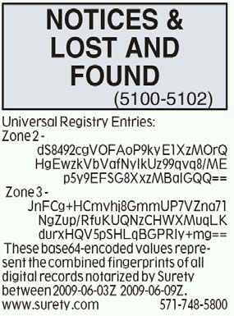
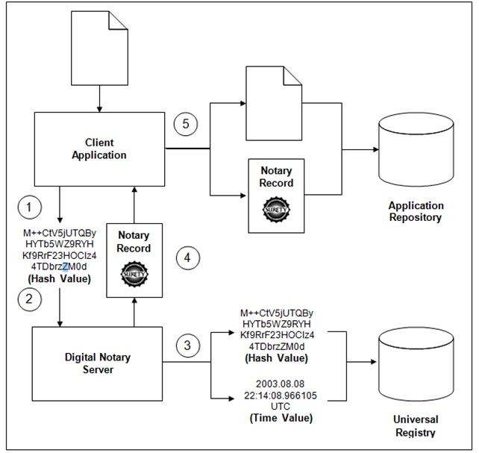
Tamper Detection – Recognizing that the original document has been changed, was compromised somehow. This capability can be used as the basis for data quality auditing. This is a new process where even the accuracy of the data back-up process can be regularly checked.

Unquestionable proof – independent of their people, processes and systems – that an organization can show what their electronic records existed at a point in time, have not been altered since, and thus are rightfully owned by the organization. Our affordable AaaS (Assurance as a Service), easy-to-implement data security and quality control approach, enables organizations to be litigation- ready and protected. If ever needed, an external third-party time stamp will confirm, that people within the organization or outside the entity neither altered nor backdated any electronic data.

VaaSSM (Verification as a ServiceSM) – (see also Surety Infrastructure Server(s)) A Web based architecture that is currently being used by many enterprises abound the world for such data quality initiatives as: Tamper Detection, rigorous Data Content Assurance, EAISM (Enhanced Archive IntegritySM), Back up auditing, and legally defensible data Non-repudiation

